Algorithm PHORIZONTAL
Input: 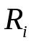: relation; 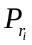:set of simple predicates
Output: 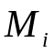: set of minterm predicates
Begin
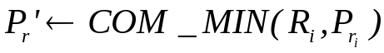
determine the set of minter predicates
determine the set of implications I
for each 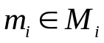 do
if 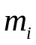 is contradictory to I then
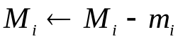
end-if
end-for
End. {PHORIZONTAL}

